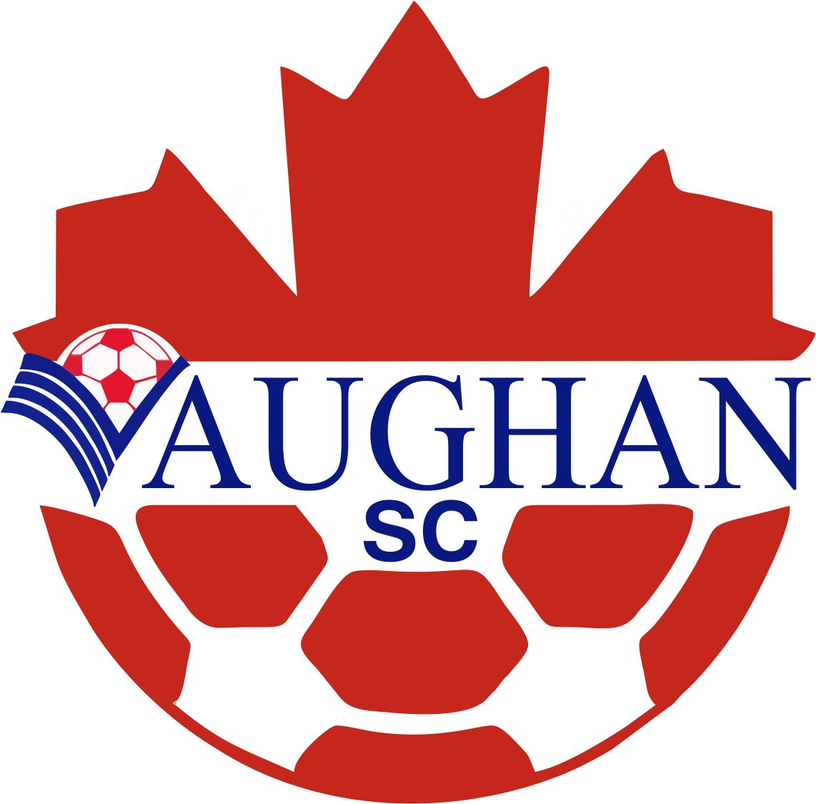 | PARENTS / SPECTATORS  CODE OF ETHICS & CONDUCT
Revised VSC AUG - 2015
As a parent / spectator of the Vaughan Soccer Club (VSC) I agree to abide by the Club’s Code of Ethics and Conduct on and off the field. I also agree to accept any action / penalties / suspension(s) levied for failure to abide by the Code of Ethics and Conduct.
- Acknowledge that children participate in sports to have fun and that the game is only for the them
- Learn and abide by the rules of the game and the policies of the Vaughan Soccer Club, Leagues and affiliates and shall support and uphold them always
- Be a positive role model for my child by always displaying good sportsmanship, professional behaviour, respect and courtesy and I will encourage good sportsmanship and fair play from my child at all times
- Support my child’s coach / coaching staff and attempt to resolve any issues / disagreements in a professional and courteous manner
- Respect the referees and game officials and their authority during every game and I will not dispute, challenge, question, or ague any call
- No swearing, no use of profanity and no criticizing of any member of the opposing team, players, coaching staff, parents / spectators, by word of mouth or by gesture of any kind
- Applaud and admire the skill and good plays of both teams and all athletes on the field
- Never criticize, ridicule, or yell at the opposing teams spectators, coaching staff or players
- Respect the rights, dignity and worth of every member (i.e. players, parents / spectators) of the Vaughan Soccer Club, game officials, associated leagues and all governing bodies
- Always maintain the highest of principles, integrity, dignity, professionalism, sportsmanship and maintain the highest of standards of personal conduct and behaviour on and off the field: parents / spectators behaviour must be such as to bring credit to yourself, your team and the VSC organization.
- Must always , exercise self-control, demonstrate excellent behaviour, be considerate of others, be courtesy and exhibit good manners
- Demand and encourage a sports environment that is free of from drugs, alcohol, and tobacco and refrain from their use at all games, training and practices
- Be humble in victory and gracious in defeat
- The VSC recognizes the importance of using social media services to improve communications with our community and club members. These services, include, Facebook, YouTube, Twitter, Instagram, and multiple VSC Micro Sites. To ensure that these social media services are used in a positive matter, the VSC has developed guidelines which members need to adhere to. (Please ensure that you are aware of this guidelines in our Social Media Policy which can be downloaded from our VSC website. (see link attached) http://vaughansoccer.com/soccerclub/index.php/member-information/club-information/policies-and-regulations/social-media-policy
Violation of the CODE OF ETHICS AND CONDUCT, Club Policy and by-laws and / or rules of the game will be subject to disciplinary action, which will be over and above any action / discipline / suspension imposed by any associated leagues, York Region Soccer Association and / or Ontario Soccer Association, which could include, but is not limited to the following:
- Written warning from the Club
- Suspension from attending games
- Expulsion from the Club
Vaughan Soccer Club

I, _________________________________, have read, understand and agree to abide by the above guidelines. I also agree to accept any action/penalties levied for failure to abide by the Code of Ethics and Conduct

Signature: ___________________________________ Date: ___________________________

