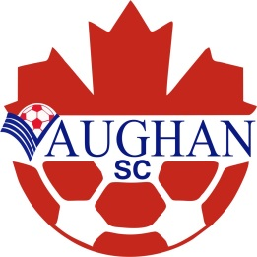
PLAYER 1 YEAR UP WAIVER FORM
PO Box 852, 11151 Keele St. Maple., ON L6A 1S1
T. 905-832-0911 F. 905-832-0624
www.vaughansoccer.com

Date: _________________________

I, __________________________________________________________ understand that my child, ______________________________________________ will be playing with players that are (1) one year older. I am aware that the Vaughan Soccer Club does not recommend this decision. As the child’s parent/legal guardian I take full responsibility for any injury that may be suffered while participating in any/all Vaughan Soccer Club programs. I, also understand that the above mentioned child will not be guaranteed equal playing time.

_________________________________________________________________________
Parent/Legal Guardian’s Full Name (please print)

_________________________________________________________________________
Signature of Parent/Legal Guardian

OSA Evaluation Form must be signed by Parent/Guardian and said form must then be reviewed and signed by Club Technical Director approving the playing up waiver.

